
ATLIQ HOSPITALITY PERFORMANCE REPORT

Hotel Performance Report & Analysis

Overview:
Our hotel has achieved an impressive 94.41K bookings, with an average guest rating of 3.62, based on 56.5K ratings that represent 60% of successful bookings. However, striving to reach 100% guest ratings presents a substantial opportunity to enhance our reputation, increase revenue, and booster market competitiveness, ultimately attracting more customers and differentiating us from competitors.

Performance Comparison: Property Ratings
When comparing the ratings of our properties:
- Atliq Season has the lowest rating of 2.29, which is 58.1% lower than the average rating of 3.62.
- Atliq Grand performs slightly better with a rating of 3.10, which is 16.9% higher than Atliq Season but 14.4% lower than the average rating.
Clearly, Atliq Blu has been performing at a significantly higher level than Atliq Season and Atliq Grand, highlighting the need for focused efforts to improve service quality at Atliq Season, aiming to elevate its performance closer to the overall average.

City Rating Comparison
- Bangalore has an average rating of 3.41, which is 5.8% lower than the average rating of 3.62.
- Mumbai stands out with a higher rating of 3.65, outperforming Bangalore by 6.6%.
To close this gap and improve the guest experience, particularly in Bangalore, focusing on service quality enhancements will be crucial to aligning the city’s ratings with the overall average.

City Performance Revenue Vs Bookings

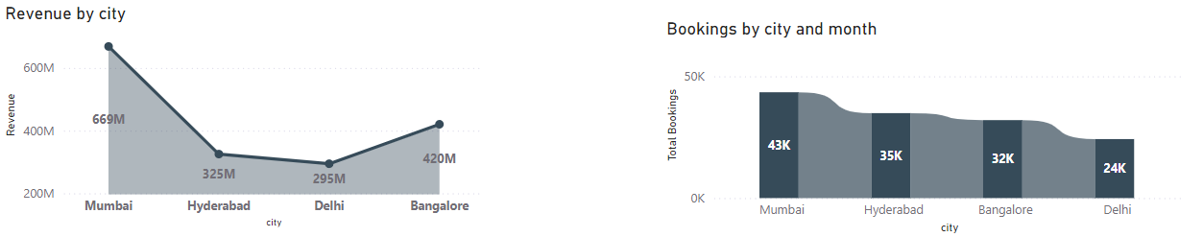

Revenue and Booking Comparison Across Cities
Analysing revenue and bookings across key cities, Mumbai leads in both metrics:
- Mumbai: 669M revenue, 43,455 bookings.
- Bangalore: 420M revenue, 32,016 bookings.
- Hyderabad: 352M revenue, 34,888 bookings.
- Delhi: 294M revenue, 24,231 bookings.

Key Insights:

- Mumbai vs. Hyderabad: Mumbai’s revenue is 89.91% higher than Hyderabad's, with 24.74% more bookings.
- Mumbai vs. Bangalore: Mumbai’s revenue is 59.3% higher than Bangalore's, with 35.74% more bookings.
- Mumbai vs. Delhi: Mumbai’s revenue is 127.55% higher than Delhi's, with 79.32% more bookings.
- Hyderabad vs. Bangalore: Hyderabad’s revenue is 16.66% higher than Bangalore's, with 8.97% more bookings.
- Hyderabad vs. Delhi: Hyderabad generates 19.73% more revenue than Delhi, with 43.96% more bookings.
- Bangalore vs. Delhi: Bangalore’s revenue is 42.86% higher than Delhi's, with 32.11% more bookings.

Judgment: Mumbai outperforms all cities significantly, especially in comparison with Delhi. While Hyderabad shows slightly better performance than Bangalore, the latter still outperforms Delhi in both revenue and bookings. Moving forward, focusing on replicating Mumbai’s success and targeting improvements in Bangalore and Delhi will be essential to closing performance gaps and driving further growth.

Properties Performance Revenue Vs Bookings

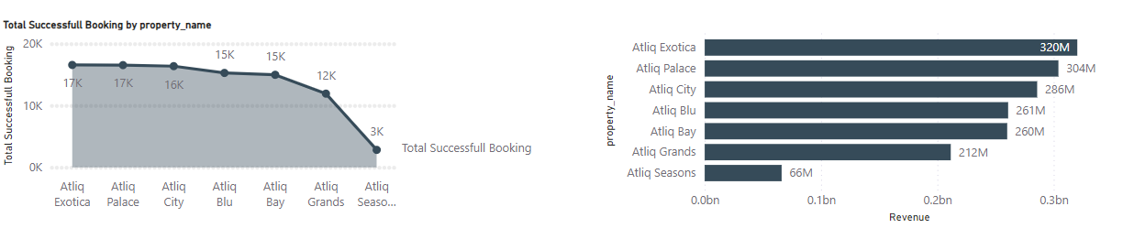

Performance Comparison: Atliq Properties
Revenue and bookings for various Atliq properties:
- Atliq Exotica: 320M revenue, 16,600 bookings.
- Atliq Palace: 304M revenue, 16,600 bookings.
- Atliq City: 286M revenue, 16,400 bookings.
- Atliq Blu: 261M revenue, 15,300 bookings.
- Atliq Bay: 260M revenue, 15,000 bookings.
- Atliq Grands: 212M revenue, 11,900 bookings.
- Atliq Seasons: 66M revenue, 2,800 bookings.
Key Insights:
- Atliq Exotica and Atliq Palace lead with the highest revenue of 320M and 304M respectively, generating 16,600 bookings each.
- Atliq City is close behind with 286M in revenue and 16,400 bookings.
- Atliq Blu and Atliq Bay perform well with 261M and 260M in revenue, but lag slightly behind the top performers.
- Atliq Grands shows a notable drop in both revenue (212M) and bookings (11,900).
- Atliq Seasons significantly underperforms with 66M in revenue and only 2,800 bookings.
Percentage Improvement:
- Atliq Exotica vs. Atliq Palace: 5.26% higher revenue for Atliq Exotica, with the same bookings.
- Atliq Exotica vs. Atliq City: 11.9% higher revenue for Atliq Exotica, with 200 more bookings.
- Atliq Exotica vs. Atliq Blu: 22.6% higher revenue for Atliq Exotica, with 1,300 more bookings.
- Atliq Exotica vs. Atliq Bay: 23.1% higher revenue for Atliq Exotica, with 1,600 more bookings.
- Atliq Exotica vs. Atliq Grands: 51.89% higher revenue for Atliq Exotica, with 4,700 more bookings.
- Atliq Exotica vs. Atliq Seasons: 384.8% higher revenue for Atliq Exotica, with 13,800 more bookings.
Judgment: Atliq Exotica is the top performer, with the highest revenue and consistent bookings. Atliq Palace and Atliq City are strong competitors, but Atliq Blu, Atliq Bay, Atliq Grands, and especially Atliq Seasons show significant room for improvement. Notably, Atliq Seasons underperforms severely, both in revenue and bookings, and should be prioritized for improvement.

Overall Conclusion:
The hotel has demonstrated strong performance with 94.41K bookings and an average guest rating of 3.62. However, there remains significant potential for growth, particularly in areas where service quality and guest satisfaction can be enhanced. While Atliq Blu stands out as the top performer in both property ratings and guest satisfaction, other properties such as Atliq Season and Atliq Grands are underperforming and need targeted efforts to improve service quality. However, striving to reach 100% guest ratings presents a substantial opportunity to enhance our reputation, increase revenue, and booster market competitiveness, ultimately attracting more customers and differentiating us from competitors.

City performance reveals that Mumbai is leading in both revenue and bookings, far outperforming other cities, especially Delhi. Bangalore, though performing well, shows room for improvement in both ratings and revenue, while Hyderabad is slightly ahead of Bangalore but still lags behind Mumbai. Replicating Mumbai's success and focusing on boosting performance in Bangalore and Delhi will be crucial for sustaining growth.
Atliq Exotica is the standout property in terms of revenue and bookings, while Atliq Seasons shows substantial underperformance and must be prioritized for improvement. Focused improvements in these underperforming areas will be key to closing performance gaps and achieving overall growth.
To drive sustained growth and strengthen market competitiveness, the hotel must continue to enhance the guest experience, optimize marketing strategies, and implement focused improvements at underperforming properties and cities. By elevating service quality and refining operational strategies, the hotel will be well-positioned for long-term success in both bookings and revenue generation.

